How to connect an instance or virtual machine to WinSCP

* Click on new tab you will able to see a one login page select New Site
* In the session, for File protocol select SFTP
* Host name: Give the public IP Address
* User name: In the AWS while connecting an Instance you will see a username

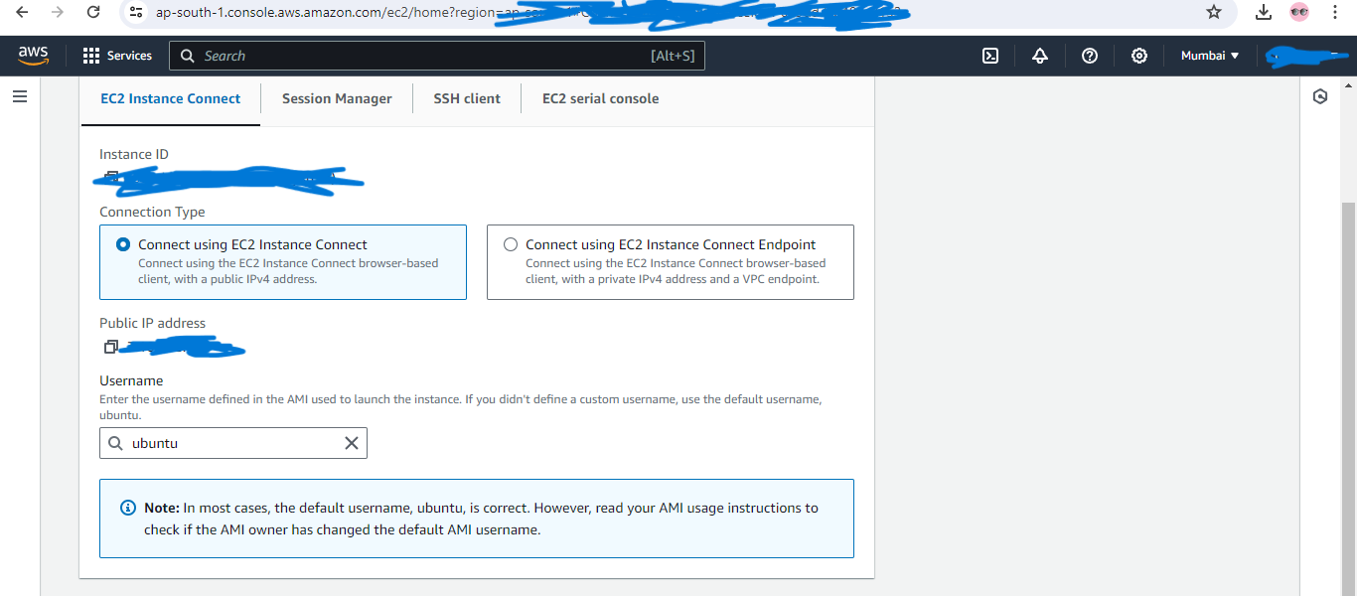

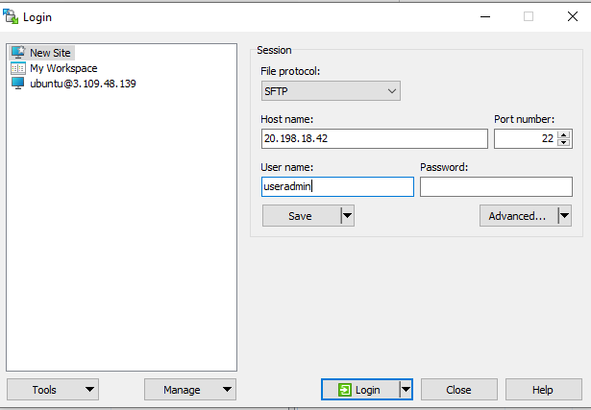

* After giving IP & Username click on Advanced you will get a popup on left side bar select SSH Authentication

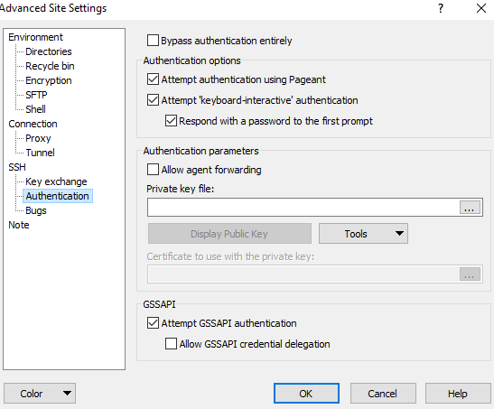

In the Private Key file you will have to select .pem file

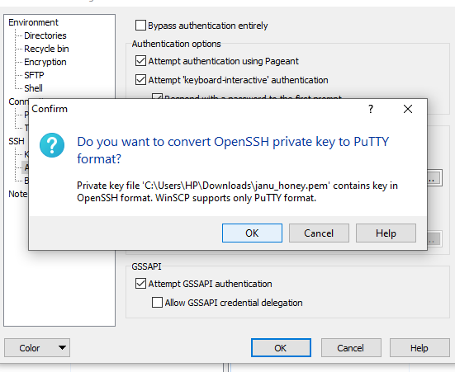

.pem will automatically convert into Putty format save to desktop.

And in the Private key select putty format save & ok

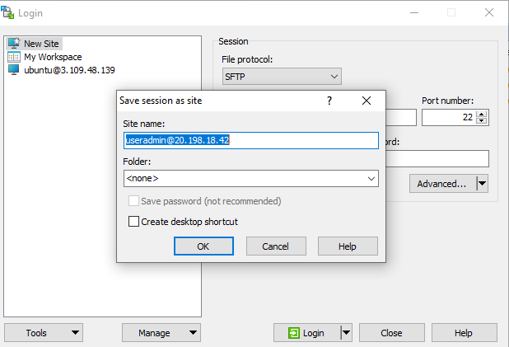

Again Click on OK and LOGIN